### **Week 1 Assessment – Forest Fire Detection Using Deep Learning**

#### **1. What is DL (Deep Learning)?**

Deep Learning is a subset of machine learning that utilizes neural networks with multiple layers to model complex patterns in data. It's particularly effective in tasks like image recognition, speech processing, and natural language understanding. Unlike traditional machine learning, deep learning automatically extracts features from raw data using hierarchical representations.

#### **2. What is a Neural Network and its Types?**

A Neural Network is a computational model inspired by the human brain, consisting of layers of interconnected nodes (neurons) that process input data and learn to make decisions.

**Types of Neural Networks:**

* **Feedforward Neural Networks (FNN):** Data flows in one direction, from input to output.
* **Convolutional Neural Networks (CNN):** Ideal for image data, uses filters to detect features like edges or textures.
* **Recurrent Neural Networks (RNN):** Suitable for sequential data like time series or language.
* **Generative Adversarial Networks (GAN):** Comprises two networks (generator and discriminator) that compete to produce realistic data.
* **Radial Basis Function Networks (RBFN):** Uses radial basis functions as activation functions; useful in function approximation.

#### **3. What is CNN in Simple Words?**

A Convolutional Neural Network (CNN) is a specialized neural network designed for processing structured grid data like images. It automatically detects patterns such as edges, colors, and shapes through filters (kernels) that slide over the input, making it highly effective for image classification and object detection tasks.

#### **4. Project Pipeline: Forest Fire Detection Using CNN**

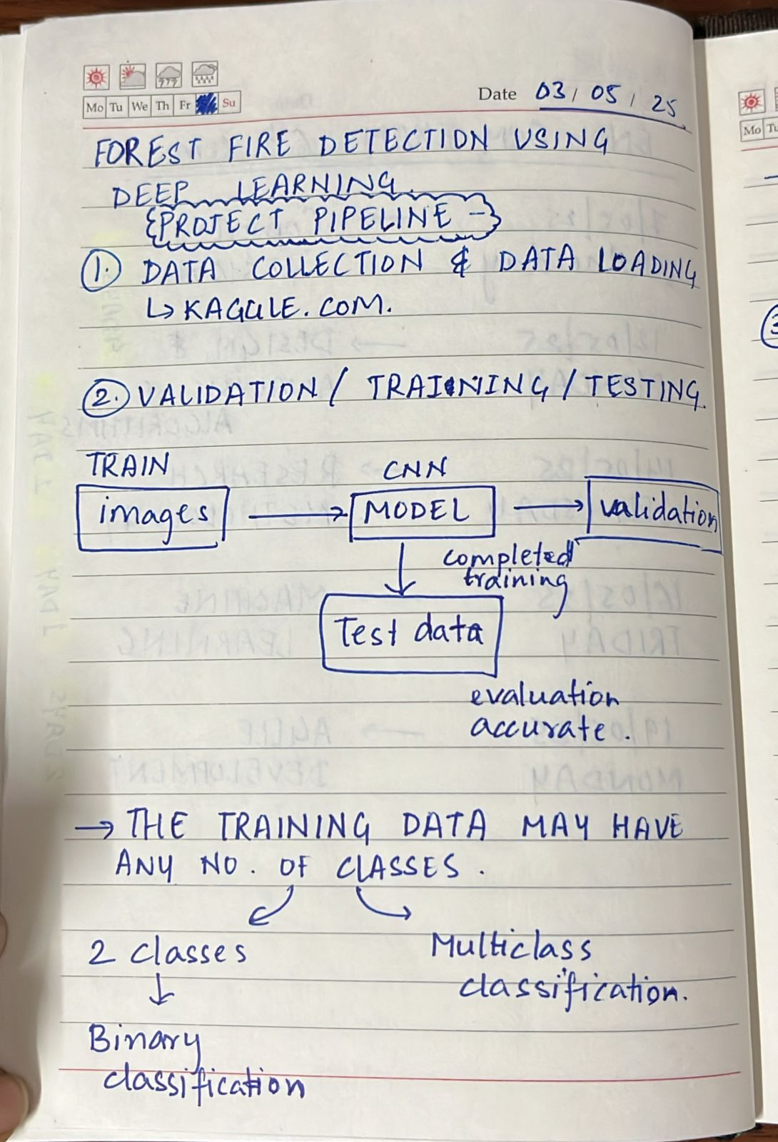

**Step 1: Data Collection and Loading**

* **Source:** Utilize datasets from [Kaggle](https://www.kaggle.com/) containing labeled images of forest fires.
* **Platform:** Employ [Google Colab](https://colab.google/) for data loading and model development, leveraging its cloud-based resources for efficient computation.
* **Data Splitting:**
  + **Training Set:** Used to train the model.
  + **Validation Set:** Used to tune model parameters and prevent overfitting.
  + **Testing Set:** Used to evaluate the final model's performance on unseen data.

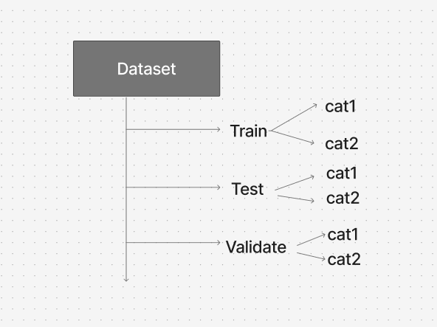

**Step 2: Image Processing and Augmentation**

* **Image Processing:** Resize all images to a uniform size to ensure consistency in model input dimensions.
* **Image Augmentation:** Apply techniques like rotation, flipping, and scaling to increase dataset diversity, which helps in improving model generalization and reducing overfitting.

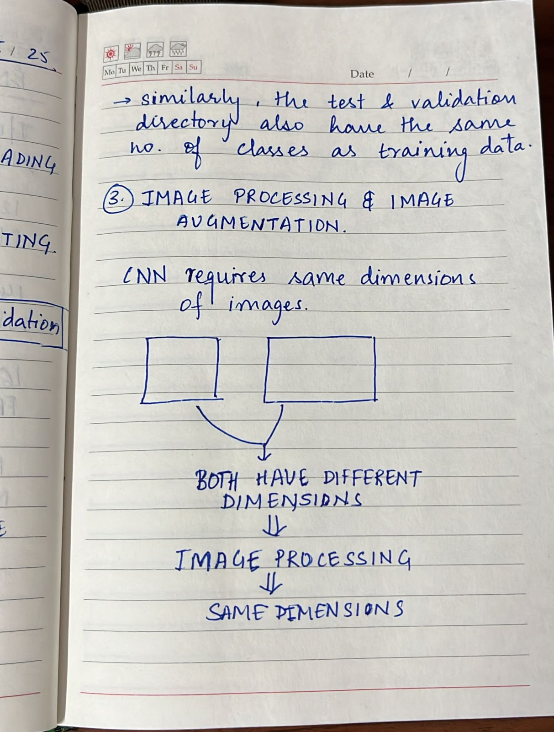

**Step 3: CNN Model Building**

* **Architecture Design:** Construct a CNN with layers such as convolutional layers, pooling layers, and fully connected layers tailored to extract and learn features relevant to forest fire detection.
* **Compilation:** Define loss functions and optimizers suitable for binary classification tasks.
* **Training:** Feed the processed and augmented data into the model, allowing it to learn distinguishing features between fire and non-fire images.

**Step 4: Testing and Evaluation**

After training your CNN model on the forest fire image dataset, it's essential to assess how well it performs. This step ensures the model generalizes well and doesn't just memorize training data.

#### **Testing the Model**

**1. What is Testing?** Testing involves feeding the **test dataset** (unseen during training/validation) into the model to check its performance. This simulates real-world conditions.

**2. Why is Testing Important?** It helps determine if the model can correctly identify forest fire and non-fire images in real-life scenarios.

**3. Common Techniques in Testing:**

* Feed the **test images** to the trained model.
* Get the model’s **predicted output** (fire/no fire).
* Compare predictions with the actual **ground truth labels**.

**Performance Metrics:** Evaluate the model using metrics like accuracy, precision, recall, and F1-score to assess its effectiveness.

**Model Tuning:** Based on evaluation results, fine-tune the model parameters to enhance performance.

The goal of testing and evaluation is not just high accuracy, but robustness and reliability in real-world usage. For a critical task like forest fire detection, even one missed fire image can be dangerous—so a balance of high recall and high precision is key.